CS 385 – Progress Report II

Rachael Grabowski: Diagrams, progress report  
Michael Lang: Code

# I. Diagrams

## Single Cycle Complete Datapath for R-type

Diagram is viewed best when document size is 150% or larger.

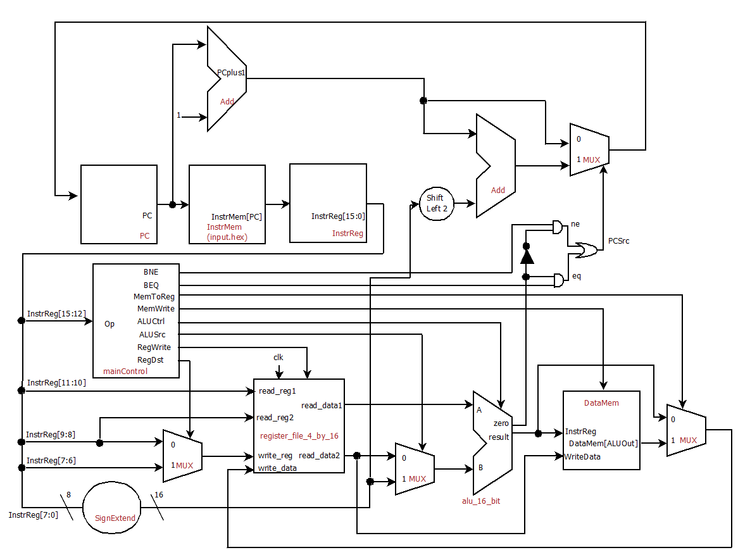

# II. Verilog Source Code

## module alu_1_bit(result, c_out, a, b, less, c_in, op);

input a, b;

input less;

input c_in;

input [2:0] op;

output result, c_out;

wire m, n, p, q, r;

not g1(m, b);

mux_2_to_1 mux1(n, b, m, op[2]);

and g2(p, a, n);

or g3(q, a, n);

full_adder fa(r, c_out, a, n, c_in);

mux_4_to_1 mux2(result, p, q, r, less, op[1:0]);

endmodule

## module alu_1_bit_msb(result, overflow, set, c_out, a, b, less, c_in, op);

input a, b;

input less;

input c_in;

input [2:0] op;

output result, overflow, set, c_out;

wire m, n, p, q;

not g1(m, b);

mux_2_to_1 mux1(n, b, m, op[2]);

and g2(p, a, n);

or g3(q, a, n);

full_adder fa(set, c_out, a, n, c_in);

mux_4_to_1 mux2(result, p, q, set, less, op[1:0]);

xor g4(overflow, c_out, c_in);

endmodule

## module alu_4_bit(result, zero, c_out, a, b, less, c_in, op);

input [3:0] a;

input [3:0] b;

input less;

input c_in;

input [2:0] op;

output [3:0] result;

output zero, c_out;

wire p, q, r, s, t;

alu_1_bit alu_0(result[0], p, a[0], b[0], less, c_in, op),

alu_1(result[1], q, a[1], b[1], 0, p, op),

alu_2(result[2], r, a[2], b[2], 0, q, op),

alu_3(result[3], c_out, a[3], b[3], 0, r, op);

or g1(s, result[0], result[1]),

g2(t, result[2], result[3]);

nor g3(zero, s, t);

endmodule

## module alu_4_bit_last(result, overflow, set, zero, c_out, a, b, c_in, op);

input [3:0] a;

input [3:0] b;

input c_in;

input [2:0] op;

output [3:0] result;

output overflow, set, zero, c_out;

wire p, q, r, s, t;

alu_1_bit alu_0(result[0], p, a[0], b[0], 0, c_in, op),

alu_1(result[1], q, a[1], b[1], 0, p, op),

alu_2(result[2], r, a[2], b[2], 0, q, op);

alu_1_bit_msb alu_3(result[3], overflow, set, c_out, a[3], b[3], 0, r, op);

or g1(s, result[0], result[1]),

g2(t, result[2], result[3]);

nor g3(zero, s, t);

endmodule

## module alu_16_bit(result, overflow, zero, c_out, a, b, op);

input [15:0] a;

input [15:0] b;

input [2:0] op;

output [15:0] result;

output overflow, zero, c_out;

wire p, q, r, s, t, u, v, w, x;

wire less;

alu_4_bit alu_0(result[3:0], s, p, a[3:0], b[3:0], less, op[2], op),

alu_1(result[7:4], t, q, a[7:4], b[7:4], 0, p, op),

alu_2(result[11:8], u, r, a[11:8], b[11:8], 0, q, op);

alu_4_bit_last alu_3(result[15:12], overflow, less, v, c_out, a[15:12], b[15:12], r, op);

and g1(w, s, t),

g2(x, u, v),

g3(zero, w, x);

endmodule

## module d_flip_flop(D,CLK,Q);

input D,CLK;

output Q;

wire CLK1, Y;

not not1 (CLK1,CLK);

d_latch D1(D,CLK, Y),

D2(Y,CLK1,Q);

endmodule

## module d_latch(D,C,Q);

input D,C;

output Q;

wire x,y,D1,Q1;

nand nand1 (x,D, C),

nand2 (y,D1,C),

nand3 (Q,x,Q1),

nand4 (Q1,y,Q);

not not1 (D1,D);

endmodule

## module decoder_2_to_4(out, sel);

input [1:0] sel;

output [3:0] out;

wire not_sel0, not_sel1;

not n0(not_sel0, sel[0]),

n1(not_sel1, sel[1]);

and a0(out[0], not_sel0, not_sel1),

a1(out[1], sel[0], not_sel1),

a2(out[2], not_sel0, sel[1]),

a3(out[3], sel[0], sel[1]);

endmodule

## module full_adder(sum, c_out, a, b, c_in);

input a, b, c_in;

output sum, c_out;

wire p, q, r;

half_adder ha1(p, q, a, b),

ha2(sum, r, p, c_in);

or g1(c_out, r, q);

endmodule

## module half_adder(sum, c_out, a, b);

input a, b;

output sum, c_out;

xor g1 (sum, a, b);

and g2 (c_out, a, b);

endmodule

## module mux_2_to_1(x, a, b, sel);

input a, b, sel;

output x;

wire p, q, r;

not g1 (p, sel);

and g2 (q, a, p),

g3 (r, b, sel);

or g4 (x, q, r);

endmodule

## module mux_4_to_1(x, a, b, c, d, sel);

input a, b, c, d;

input [1:0] sel;

output x;

wire p, q;

mux_2_to_1 mux1(p, a, b, sel[0]),

mux2(q, c, d, sel[0]),

mux3(x, p, q, sel[1]);

endmodule

## module mux_4_to_2(x, a, b, sel);

input [1:0] a, b;

input sel;

output [1:0] x;

mux_2_to_1 mux1(x[0], a[0], b[0], sel),

mux2(x[1], a[1], b[1], sel);

endmodule

## module mux_32_to_16(x, a, b, sel);

input [15:0] a, b;

input sel;

output [15:0] x;

mux_2_to_1 m0(x[0], a[0], b[0], sel),

m1(x[1], a[1], b[1], sel),

m2(x[2], a[2], b[2], sel),

m3(x[3], a[3], b[3], sel),

m4(x[4], a[4], b[4], sel),

m5(x[5], a[5], b[5], sel),

m6(x[6], a[6], b[6], sel),

m7(x[7], a[7], b[7], sel),

m8(x[8], a[8], b[8], sel),

m9(x[9], a[9], b[9], sel),

m10(x[10], a[10], b[10], sel),

m11(x[11], a[11], b[11], sel),

m12(x[12], a[12], b[12], sel),

m13(x[13], a[13], b[13], sel),

m14(x[14], a[14], b[14], sel),

m15(x[15], a[15], b[15], sel);

endmodule

## module mux_64_to_16(x, a, b, c, d, sel);

input [15:0] a, b, c, d;

input [1:0] sel;

output [15:0] x;

mux_4_to_1 m0(x[0], a[0], b[0], c[0], d[0], sel),

m1(x[1], a[1], b[1], c[1], d[1], sel),

m2(x[2], a[2], b[2], c[2], d[2], sel),

m3(x[3], a[3], b[3], c[3], d[3], sel),

m4(x[4], a[4], b[4], c[4], d[4], sel),

m5(x[5], a[5], b[5], c[5], d[5], sel),

m6(x[6], a[6], b[6], c[6], d[6], sel),

m7(x[7], a[7], b[7], c[7], d[7], sel),

m8(x[8], a[8], b[8], c[8], d[8], sel),

m9(x[9], a[9], b[9], c[9], d[9], sel),

m10(x[10], a[10], b[10], c[10], d[10], sel),

m11(x[11], a[11], b[11], c[11], d[11], sel),

m12(x[12], a[12], b[12], c[12], d[12], sel),

m13(x[13], a[13], b[13], c[13], d[13], sel),

m14(x[14], a[14], b[14], c[14], d[14], sel),

m15(x[15], a[15], b[15], c[15], d[15], sel);

endmodule

## module register_16_bit(out, in, clk);

input [15:0] in;

input clk;

output [15:0] out;

d_flip_flop d0(in[0], clk, out[0]),

d1(in[1], clk, out[1]),

d2(in[2], clk, out[2]),

d3(in[3], clk, out[3]),

d4(in[4], clk, out[4]),

d5(in[5], clk, out[5]),

d6(in[6], clk, out[6]),

d7(in[7], clk, out[7]),

d8(in[8], clk, out[8]),

d9(in[9], clk, out[9]),

d10(in[10], clk, out[10]),

d11(in[11], clk, out[11]),

d12(in[12], clk, out[12]),

d13(in[13], clk, out[13]),

d14(in[14], clk, out[14]),

d15(in[15], clk, out[15]);

endmodule

## module register_file_4_by_16(read_data1, read_data2, read_reg1, read_reg2, write_reg, write_data, reg_write, clk);

input [1:0] read_reg1, read_reg2, write_reg;

input [15:0] write_data;

input reg_write, clk;

output [15:0] read_data1, read_data2;

wire [3:0] w, c;

wire p;

wire [15:0] q1, q2, q3;

decoder_2_to_4 dec(w, write_reg);

and g1(p, reg_write, clk),

g2(c[1], p, w[1]),

g3(c[2], p, w[2]),

g4(c[3], p, w[3]);

register_16_bit r1(q1, write_data, c[1]),

r2(q2, write_data, c[2]),

r3(q3, write_data, c[3]);

mux_64_to_16 m1(read_data1, 0, q1, q2, q3, read_reg1),

m2(read_data2, 0, q1, q2, q3, read_reg2);

endmodule

## module MainControl(Op,Control);

input [3:0] Op;  
 output reg [9:0] Control;

always @(Op) case (Op)  
 // {RegDst, BEQ, BNE, MemtoReg, MemWrite, ALUSrc, RegWrite, ALUctl[2], ALUctl[1], ALUctl[0]}  
 4'b0000: Control <= 10'b1000001010; // add  
 4'b0001: Control <= 10'b1000001110; // sub   
 4'b0010: Control <= 10'b1000001000; // and   
 4'b0011: Control <= 10'b1000001001; // or   
 4'b0100: Control <= 10'b0000011010; // addi   
 4'b0101: Control <= 10'b0001111010; // lw   
 4'b0110: Control <= 10'b0000110010; // sw   
 4'b0111: Control <= 10'b1000001111; // slt   
 4'b1000: Control <= 10'b0100000110; // beq  
 4'b1001: Control <= 10'b0010000110; // bne   
 endcase  
endmodule

## module CPU (clock, WriteData, InstrReg);

input clock;  
 output [15:0] WriteData, InstrReg;  
 reg [15:0] PC;  
 reg [15:0] InstrMem[0:511], DataMem[0:511];  
 wire [15:0] InstrReg, SignExtend, NextPC, ReadData2, A, B, ALUOut, PCplus1, AluOrMem;  
 wire [1:0] WriteReg;  
 wire [3:0] op;  
 wire [2:0] ALUctl;  
  
 // Read hex data from text file into InstrMem  
 initial begin  
 $readmemh("input2.hex", InstrMem);  
  
 DataMem [0] = 16'h7;  
 DataMem [1] = 16'h5;  
 end  
  
 initial PC = 0;  
  
 assign InstrReg = InstrMem[PC];  
 assign SignExtend = {{8{InstrReg[7]}},InstrReg[7:0]}; // sign extension  
 MainControl mainCtrl(InstrReg[15:12], {RegDst, BEQ, BNE, MemtoReg, MemWrite, ALUSrc, RegWrite, ALUctl[2], ALUctl[1], ALUctl[0]});   
 register_file_4_by_16 regFile(A, ReadData2, InstrReg[11:10], InstrReg[9:8], WriteReg, WriteData, RegWrite, clock);  
 alu_16_bit fetch(PCplus1, unused1, unused2, unused3, PC, 1, 3'b010),  
 ex(ALUOut, unused4, Zero, unused5, A, B, ALUctl);  
  
 not g1(NotZero, Zero);  
 and g2(ne, BNE, NotZero),  
 g3(eq, BEQ, Zero);  
 or g4(PCsrc, ne, eq);  
  
 mux_4_to_2 mux1(WriteReg, InstrReg[9:8], InstrReg[7:6], RegDst);  
 mux_32_to_16 mux2(WriteData, ALUOut, DataMem[ALUOut], MemtoReg),  
 mux3(B, ReadData2, SignExtend, ALUSrc),  
 mux4(NextPC, PCplus1, SignExtend, Pcsrc);  
  
 always @(negedge clock) begin   
 PC <= NextPC;  
 if(MemWrite)  
 DataMem[ALUOut] <= ReadData2;  
 end  
endmodule  
  
// Test module  
  
module test ();  
  
reg clock;  
wire [15:0] WriteData, InstrReg;  
  
CPU test_cpu(clock, WriteData, InstrReg);  
  
always #1 clock = ~clock;  
  
initial begin  
 $display ("time clock InstrReg WriteData");  
 $monitor ("%2d %b %h %h", $time, clock, InstrReg, WriteData);  
 clock = 1;  
 #24 $finish;  
end  
endmodule

# III. Testing & Results

## Testing Code

### input2.hex

5100 // lw $1, 0($0) ==> 0101000100000000

5201 // lw $2, 1($0) ==> 0101001000000001

76c0 // slt $3, $1, $2 ==> 0111011011000000

8c08 // beq $3, $0, 8 ==> 1000110000001000

6101 // sw $1, 1($0) ==> 0110000100000001

6200 // sw $2, 0($0) ==> 0110001000000000

5100 // lw $1, 0($0) ==> 0101000100000000

5201 // lw $2, 1($0) ==> 0101001000000001

1640 // sub $1, $1, $2 ==> 0001011001000000

0000 // nop ==> 0000000000000000

## Testing Results

Please note that the warning is intentional. Since the code is reading the instructions from a file directly into a reg vector, it's leaving most of the vector uninitialized, thus causing the warning.

### Execution1

#### Screenshot

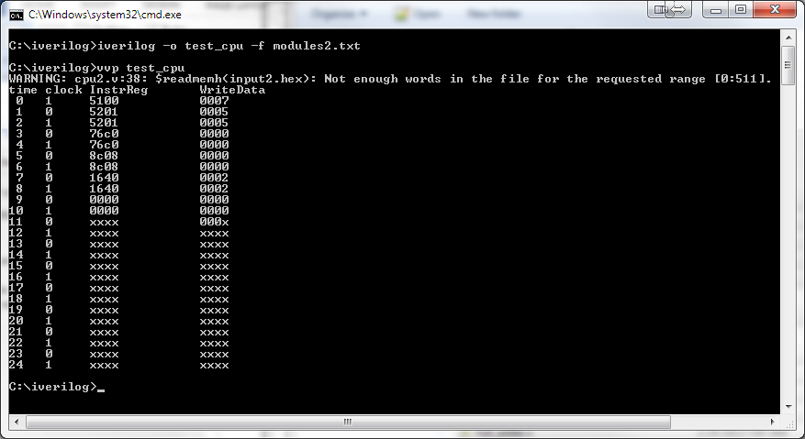

#### Plaintext

C:\iverilog>iverilog -o test_cpu -f modules2.txt

C:\iverilog>vvp test_cpu

WARNING: cpu2.v:38: $readmemh(input2.hex): Not enough words in the file for the requested range [0:511].

time clock InstrReg WriteData

0 1 5100 0007

1 0 5201 0005

2 1 5201 0005

3 0 76c0 0000

4 1 76c0 0000

5 0 8c08 0000

6 1 8c08 0000

7 0 1640 0002

8 1 1640 0002

9 0 0000 0000

10 1 0000 0000

11 0 xxxx 000x

12 1 xxxx xxxx

13 0 xxxx xxxx

14 1 xxxx xxxx

15 0 xxxx xxxx

16 1 xxxx xxxx

17 0 xxxx xxxx

18 1 xxxx xxxx

19 0 xxxx xxxx

20 1 xxxx xxxx

21 0 xxxx xxxx

22 1 xxxx xxxx

23 0 xxxx xxxx

24 1 xxxx xxxx

### Execution 2

#### Screenshot

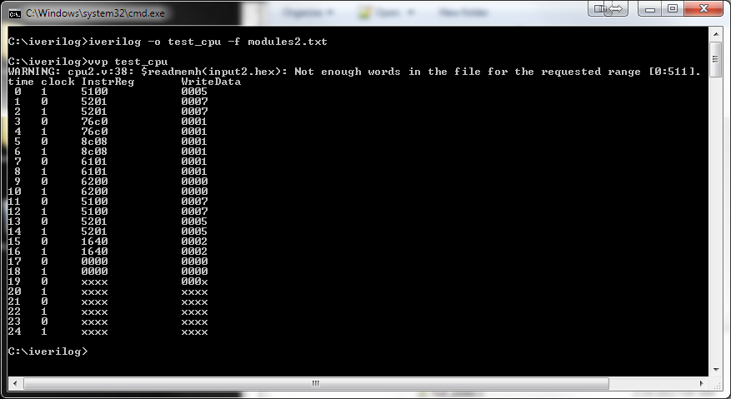

#### Plaintext

C:\iverilog>iverilog -o test_cpu -f modules2.txt

C:\iverilog>vvp test_cpu

WARNING: cpu2.v:38: $readmemh(input2.hex): Not enough words in the file for the requested range [0:511].

time clock InstrReg WriteData

0 1 5100 0005

1 0 5201 0007

2 1 5201 0007

3 0 76c0 0001

4 1 76c0 0001

5 0 8c08 0001

6 1 8c08 0001

7 0 6101 0001

8 1 6101 0001

9 0 6200 0000

10 1 6200 0000

11 0 5100 0007

12 1 5100 0007

13 0 5201 0005

14 1 5201 0005

15 0 1640 0002

16 1 1640 0002

17 0 0000 0000

18 1 0000 0000

19 0 xxxx 000x

20 1 xxxx xxxx

21 0 xxxx xxxx

22 1 xxxx xxxx

23 0 xxxx xxxx

24 1 xxxx xxxx